LAB 5 – Raja Aadhithan
Design – Single port RAM:
Output:
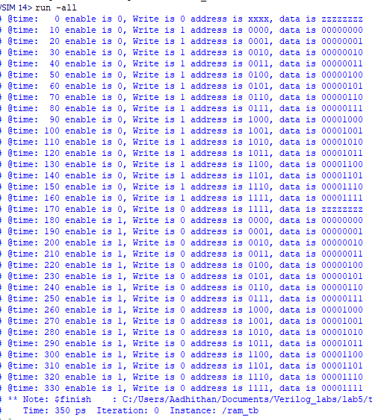
Wave:
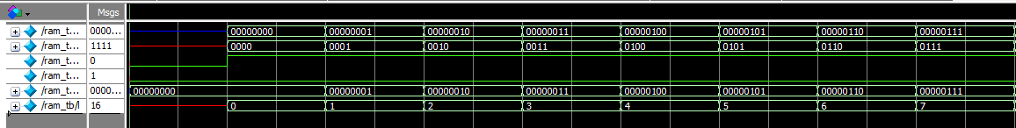
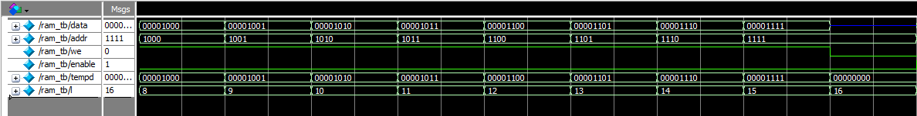
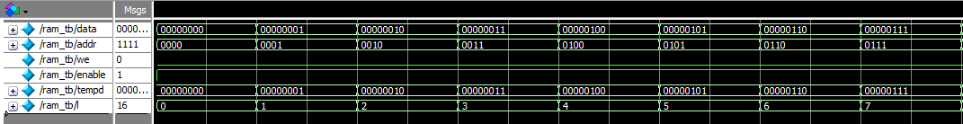
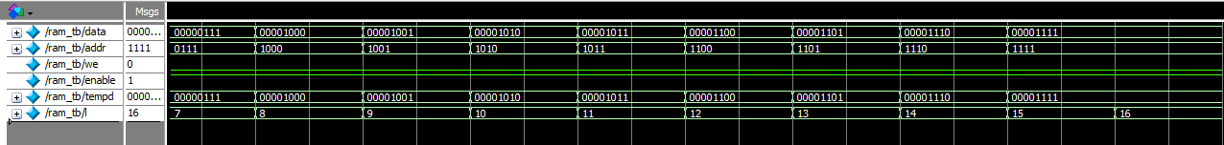
RTL:
Too lengthy to crop.

Exercise:
Design : FIFO:

Wave: Zoomed out version
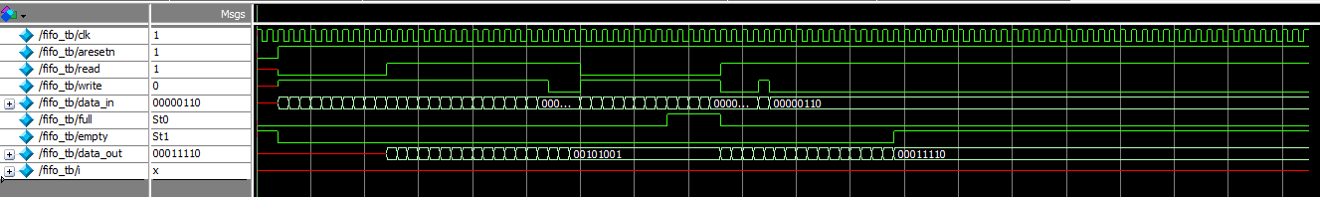

Output:
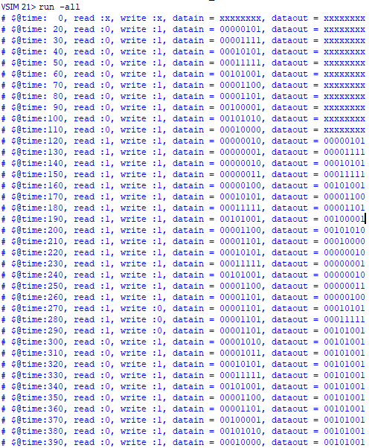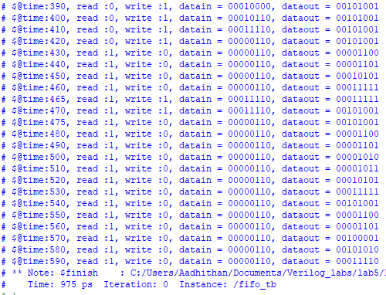
RTL:
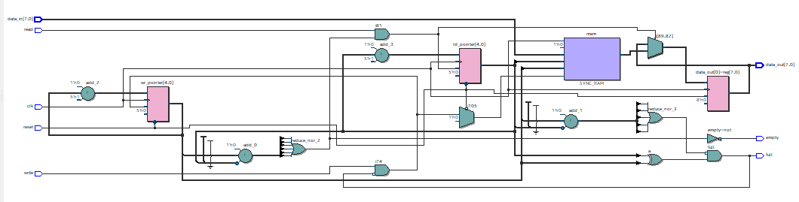
Assignments:
Design : 16x8 dual port Ram
Wave:
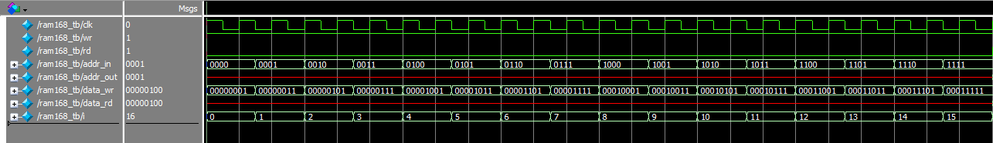
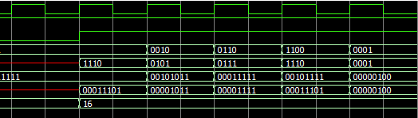
Output:
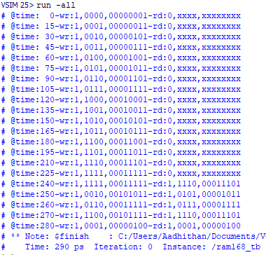

RTL:
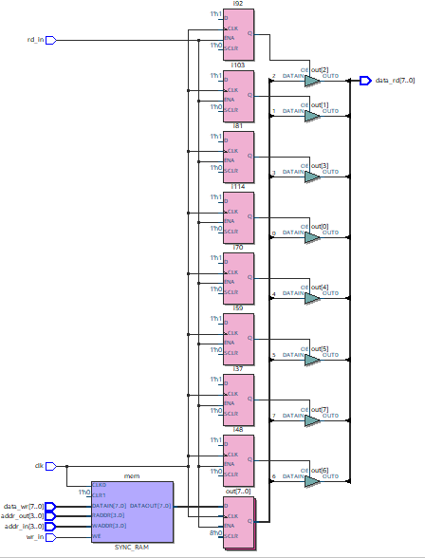
Design : 8x16 Ram:
Wave:
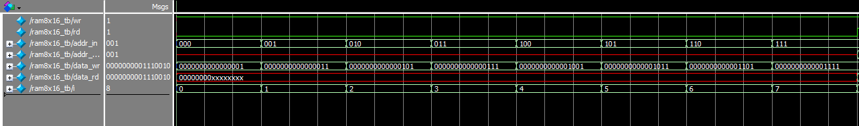
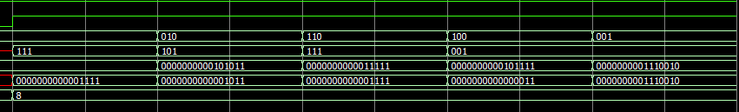
Output:
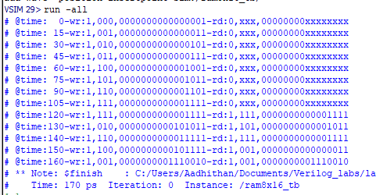
RTL:
Too length to attach.

Design : 4 bit SISO
Wave:
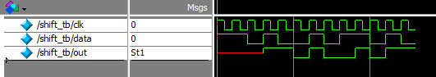
Output:
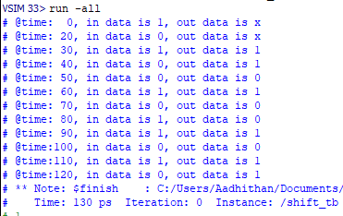
RTL:
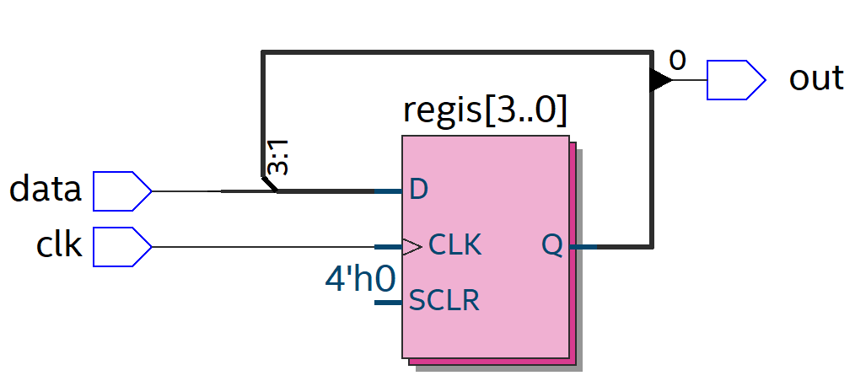

Design : Clock buffer:
Wave:
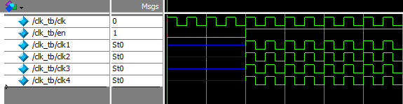
Output:
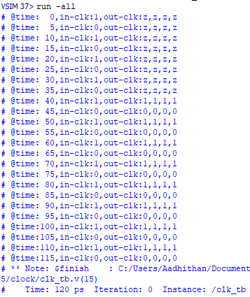
RTL:
